|  |
| --- |
|  |
| Urban and Rural Shelter Program after the 2010 Earthquake in Haiti. |
| **Linking relief to development.** |

|  |
| --- |
| **|Henk Meijerink, Koen Wagenbuur, Jip Nelissen and James Morgan**  **11/7/2012**  **Ver05** |

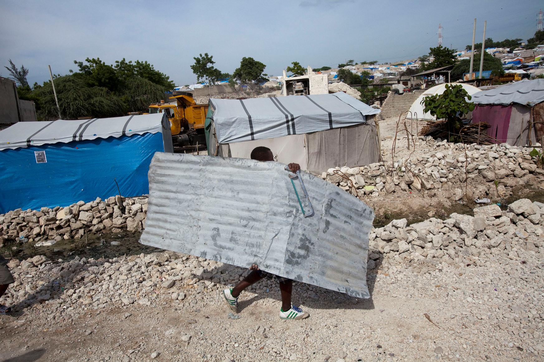

Table of Contents

0.FOREWORD 2

1. INTRODUCTION 2

1.1 Haiti before the earthquake 3

1.2 The Earthquake 3

1.3 Getting Started 4

1.4 Social Capital 6

2 THE RURAL SHELTER PROJECT 8

2.1 Context and Culture 8

2.2 T-Shelter Design 10

2.3 Towards to permanent housing 12

2.4 Implementation 13

2.5 Summary 16

3 THE URBAN SHELTER PROJECT 18

3.1 Context and Culture 18

3.2 Adapting Urban Shelters 20

3.3 Debris and recycling of materials. 21

3.4 Repairing and Retrofitting 22

3.5 Integrated Neighbourhood Approach 23

*The initial phase; Villa Rosa and Tisous* 25

3.6 Owner Driven Housing 28

*Training and awareness* 29

*House construction (retrofit and new build)* 30

3.7 Social Protection 32

3.8 Social Capital Development 33

3.9 Livelihoods 34

3.10 Summary 35

4. Conclusion 36

4.1 Shelter design 36

4.2 Social Capital 36

4.3 Integrated Neighbourhood Approach 37

4.4 Owner Driven approach 38

4.5 Cash grants, subsidies and loans 39

4.6 Advocacy 39

5. Overview of Results 41

List of Acronyms & Abbreviations 42

# FOREWORD

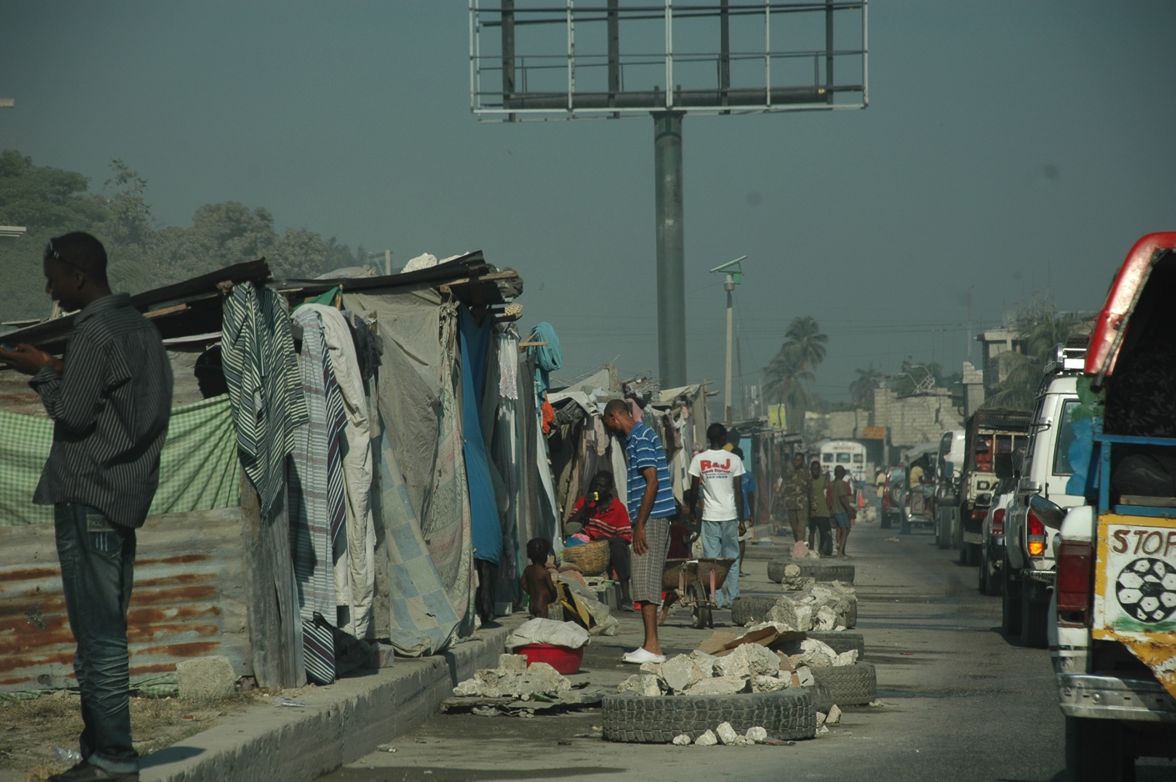

***February 2010***

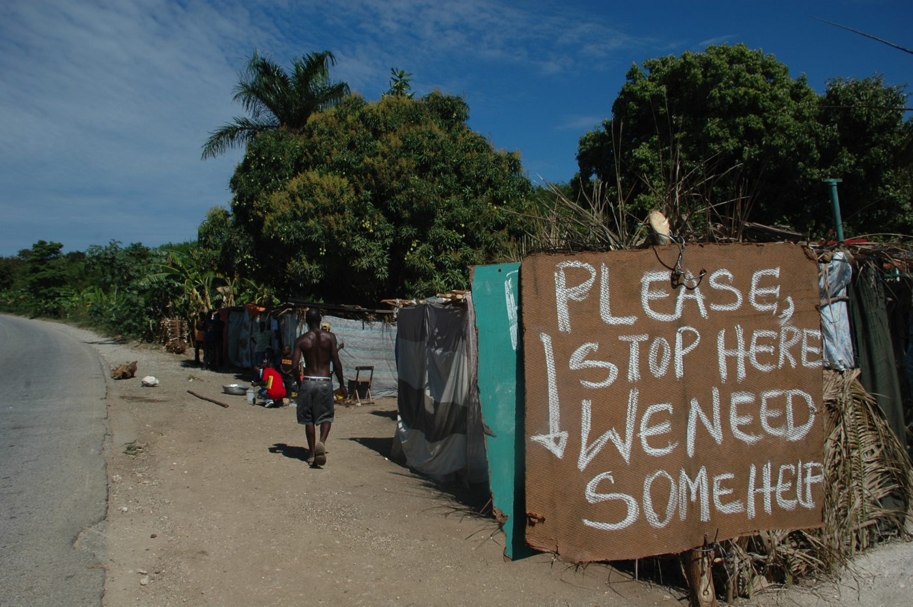

# INTRODUCTION

## 1.1 Haiti before the earthquake

The tropical, mountainous country of Haiti shares the island of Hispaniola with the Dominican Republic and lies less than 80km east of Cuba. A former French colony, Haiti gained independence in 1804 and has since struggled with both political crises and devastating natural disasters that have left the country's infrastructure close to total collapse. The Caribbean nation of Haiti is one of the least developed in the world with four out of five of its people living in poverty. Haiti ranked 149 out of 182 in the 2009 Human Development Index. Nearly 70 percent of the country's people live on less than $2 a day, 55 percent below $1.25 a day[1]. Haiti's literacy rate is 45 per cent. Infant mortality rate is high at 53 per 1.000 live births, and the prevalence of HIV among those between ages 15 and 49 is 2.2 per cent. Two-thirds of Haitians depend on agriculture and many are subsistence farmers living in rural areas. The country in general has a heavy reliance on International Aid and remittances send back by the three million Haitians living abroad. The population of the metropolitan area of Port au Prince was estimated at 2.5 to 3 million people of which an estimated 80% live in slums (“bidonvilles”).

***<Image 2.x>The earthquake made the already vulnerable Haitians even more aid depended.***

***Source; Group 5, downtown, Port au Prince, Haïti, 100305***

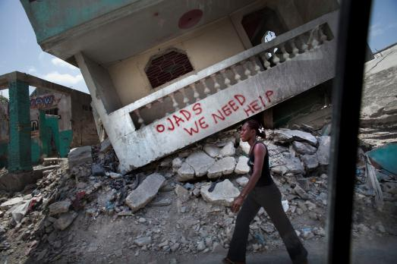

## 1.2 The Earthquake

The earthquake that struck on 12 January 2010, measuring 7.0 on the Richter scale, has hit the impoverished Caribbean nation terribly. In particular, the Ouest Province was ravaged, with the epicentre of the earthquake near Leogane, some 20 km to the South-West of the capital Port au Prince. Earthquake affected areas extend to the West and South of Port au Prince up to Jacmel on the south coast. The level of human cost was extremely high, estimated at over 200,000 deaths and affecting over 3.5 million people[2]. Infrastructure, including electricity and water, residential houses, public buildings, such as health facilities and schools, has been damaged or destroyed at an enormous scale. It was estimated that between 1.3 and 1.6 million of those affected by the earthquake were in need of shelter support.

This publication documents the intervention by the Cordaid Emergency Aid department, from the decision to participate in the international relief effort to the moment that Cordaid was able to close the project in August 2012 and hand-over the continuing reconstruction to its local partners. In the previous years, Cordaid had built experience in providing shelter to disaster stricken people in Atjeh, Sri Lanka and Pakistan, of which evaluations had brought about valuable lessons. With more than 30 years of experience in Haiti, and a partner network of more than 20 national organisations, including the Caritas network, Cordaid was well positioned to offer its expertise and its capacity for project implementation to the people of Haiti. During a live televised fund raising event on 21 January 2010 the Dutch public donated the money that enabled the intervention of a number of Dutch relief organisations, of which Cordaid was one.

***<Image 1.x> describing the impact of the earthquake and the population exposed |***

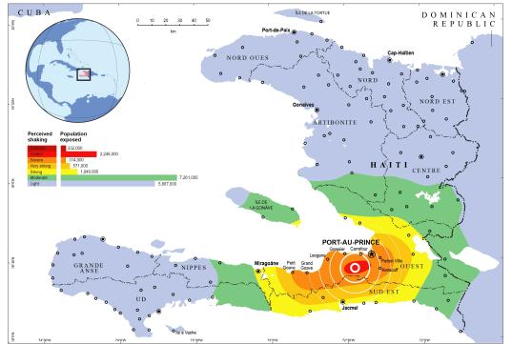***Source; UN OCHA 121001***

**1.3 Getting Started**

The first assessments of the damage caused by the earthquake were undertaken under the auspicious of the UNOSAT in the first quarter of 2010. Cordaid shelter experts were on the ground within a week of the earthquake conducting rapid assessments and feeding the information back to the UN cluster groups. As part of standard emergency response the UN established clusters per sector to coordinate the emergency and reconstruction activities. Part of the coordinating role of the Shelter Cluster was to assure an even spread of international organisations over the areas affected by the earthquake, and to avoid the duplication of proposed interventions in the same neighbourhoods.

The Haitian Ministry of Public Works, Transport and Communications (MTPTC) undertook a quick, albeit crude, damage assessment. An enormous effort was made to code all houses in one of three categories: green, for no substantial damage; yellow, for substantial damage but repairable; and red for houses that were damaged to the level where they were not longer habitable and/or formed an immediate life threatening situation.

For Cordaid, it was important to match the data that came out of the damage and needs assessment with the geographical coverage of the national organisations with which a partnership had already been established. Between February and April 2010, Cordaid experts carried out a number of rapid assessments, working closely with several of its local partner organisations. Also meetings were held with Community Based Organisations (CBOs) and local leaders. Local authorities such as the Mayor’s office and the Conseil d’Administrative Section Communale (CASEC, the elected local level representatives) provided further statistical information and showed a potential for cooperation.

The criteria that determined the areas of intervention of the Cordaid Shelter Program, included: coverage by other agencies; a matching of needs and available funding; low income area (i.e. slums); security risk levels; existing local partnership, potential for collaboration with authorities, complexities posed for reconstruction work; and potential for DRR, WASH and livelihood programmes. Within the target area Cordaid set the goal to service all households with a house tagged yellow or red by the MTPTC.

Initially in February 2010 the project targeted the rural communities of Lompre in Leogane and 7th section of Grand Goave Commune and in Port au Prince the communities of Villa Rosa and St Marie. However, when it was ascertained in May 2010 that certain badly damaged areas were not covered by any agency, Cordaid added Grand Goave city to its rural shelter program and two areas in Carrefour – Tisous and Nan Cocteau- to its urban shelter program.

***<Image 3.x> Map of Area of interventions of Cordaid Haiti***

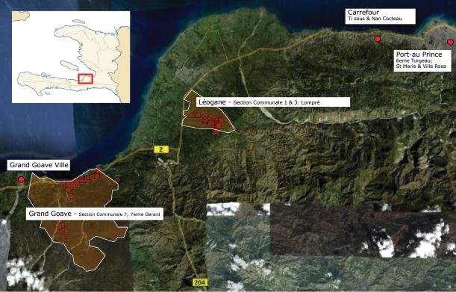***Source; Group 5, 120410***

In the urban areas of Carrefour and Port au Prince the context for a shelter program proved to be complex. There was an absence of government direction, an enormous presence of rubble that was obstructing the start and challenging land ownership issues. Consequently, while preparations for the urban programme continued, Cordaid first began implementing the shelter programme in the rural areas, where these challenges were easier to overcome. In the selected low income rural areas over 70% of the houses had collapsed or were beyond repair. Despite the debris, there was sufficient space on the plots to commence reconstruction immediately. Also, the traditionally established land titles, while not providing a formal legal base, posed few obstacles for a swift start.

Both the urban and the rural program started off with a new survey that collected social and economic data at the household level and further assessment of the damage of the houses.

In the rural communities the survey was carried out by partner organisations. In the urban areas in Carrefour and Port au Prince, but also in Grand Goave City, the teams that conducted the survey comprised of a Cordaid staff member and an inhabitant of the neighbourhood, who had been trained to conduct interviews and assessments. In total, over 11,000 families have been interviewed and their houses technically assessed. The assessment data was entered in a database and formed the basis for beneficiary selection and verification.

***<Image 4.x> Urban Complexity***

***Source; Group 5,Villa Rosa, Port au Prince, Haïti, 100523***

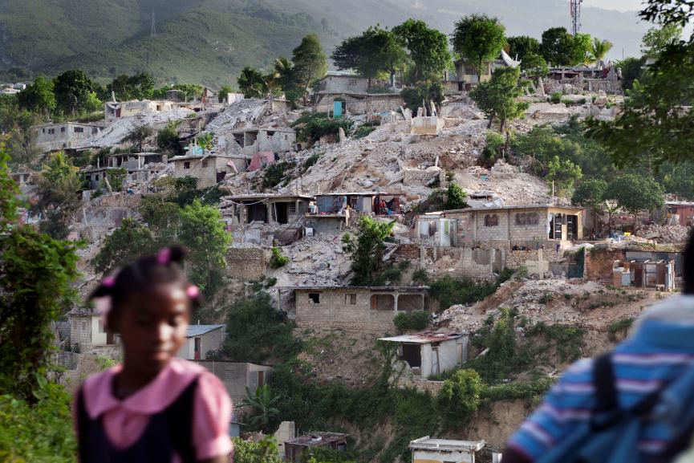

The shelter program adopted a broad definition of what constitutes shelter, which transcends the meaning of a roof over ones head. Shelter refers to the living quarters of people, which include the common spaces between houses, and it includes a healthy environment. It also means a place where one is secure, both from natural disasters, from crime and from threat of eviction. Besides the physical construction of houses, the program therefore incorporated objectives for improving Water Sanitation and Health (WaSH), Neighbourhood reconstruction, Social protection, Community Development and Livelihoods. However, a budget was formulated for the shelter program that did not allocate funding to all of these objectives. Instead, a strategy was devised to team up with other actors that could complement the components that Cordaid was implementing. From an early stage this entailed an active role for Cordaid in inviting specialized partner organisations to join forces in its intervention areas. Networking was important and provided one more reason why Cordaid took an active role in the Shelter Cluster throughout their existence, such as participating in the Technical Working Groups (TWIGs), and in the Strategic Advisory Group (SAG) advising Government on shelter approaches.

**1.4 Social Capital**

From the start of the Shelter program, developing Social Capital was included as a Specific Objective, to be achieved through strengthened organisation of - , and cooperation between, local government, community committees, and non-governmental organizations. Besides being an emergency response to the destruction of homes, the shelter program had the aim of creating a long lasting positive impact in the neighbourhoods of its intervention. For that, a well-organized community, which has the ability to take charge of its own development, is crucial. The objective was motivated by one of the key lessons learned of the previous intervention in Indonesia which was documented in the report “missed opportunities”.

An existing methodology was selected by Cordaid called Community Action Planning[3] (CAP), which is well known and accepted in Haiti. In the Community Action Planning process people are considered to be the primary resource rather than the objects of development. This approach motivates the disaster-affected people to take the lead in the planning and implementation of reconstruction activities. Community Action Planning, which develops the capacity of the communities to take appropriate action for their own development, is the framework for the implementation of actions decided by the communities. The identification of needs should not be viewed as making a “wish list” of what communities want, but as a process of understanding their present situation following a disaster.

Communities in disaster struck neighbourhoods elected representatives per sector of intervention and per socio-geographic area, typically a sub-neighbourhood of approximately 300 families. Thus, groups were established to assist in assessment, mapping, and selection, to prioritise the most vulnerable and to assist in the implementation of agreed action plans. In a next phase, representatives of these groups formed a Neighbourhood Reconstruction Committee (NRC) to assess and prioritise needs and interventions at the larger level of the neighbourhood, such as the main road and drainage infrastructure and ravine protection. Furthermore, within the communities, Focus Groups were initiated to work on specific themes, such as waste, or on proposals for small scale projects, such as footpaths. It was Cordaid’s aim that the gradual withdrawal of Cordaid in terms of hands on involvement in the neighbourhood should be met with increased involvement of local actors. In this sense, community development and CAP is also part of the exit strategy.

***<Image 5 [34.3]> Community Action Planning session of mapping priorities.***

***Source; AfH, Villa Rosa, Port au Prince, Haiti, 111027***

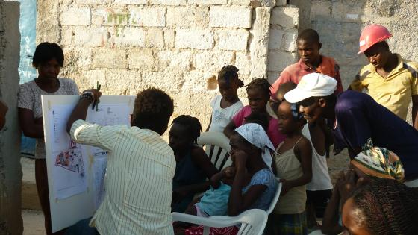

# 2 THE RURAL SHELTER PROJECT

The shelter program first took off in the areas of Lompre in Leogane, the 7th section of Grand Goave Commune, and Grand Goave city. While henceforth known as the rural shelter programme, the level of urbanisation varies between the neighbourhoods and within them. Some parts even showed characteristics that are described later in the section of the urban shelter program. However, being part of one geographical zone meant that adaptations later developed in Carrefour and Port au Prince were not applied here. The target areas of the rural shelter project include mountainous parts as well as plains. In general the rural areas show a spacious lay-out of the settlements and the common occurrence of the vernacular house.

Through the Community Action Planning (CAP) exercise, the communities in the area of the rural shelter program elected more than hundred local community leaders and representatives to take up a place in five regional committees, which became known as the Neighbourhood Reconstruction Committees (NRC). The NRCs acted as a local counterpart in each of the areas they represented. They participated in the process of beneficiary selection for the shelters, facilitated the distributions of shelter kits and materials and helped with the mobilization of and communication with the community.

## 2.1 Context and Culture

The rural vernacular of houses in Haiti is descendant from West African Architecture with influences from pre-Columbian Indian culture. In the traditional rural family house or ‘Ti Kay’ as they are known in Haitian Creole, we see many architectural elements valued by Haitian culture:

1. *Transition and Growth*

The house is designed for expansion over time. The Creole the people say ‘Piti piti zwazo fe nich’ that translated reads ‘Little by little the bird builds its nest’.

1. *Ornament and detail*

The Haitians celebrate and take pride in their homes. Homeowners often participate in the construction process, embellishing surface renders with art and creating niches to place their objects of sentimental value.

1. *Archetypical elements*

Based on their culture of spirituality and Voodoo beliefs certain architectural elements have emerged that have become archetypal in the Haitian House: 2 long front doors, 1 back door to let out the spirits; shutter windows; and the traditional ‘Galri’ or Porch, the nexus of rural living.

***<Image 6.x> Rural Vernacular of the Ti Kay and its characteristics***

***Source; Group 5, 7ieme Gerard, Grand Goave, Haiti, 100414***

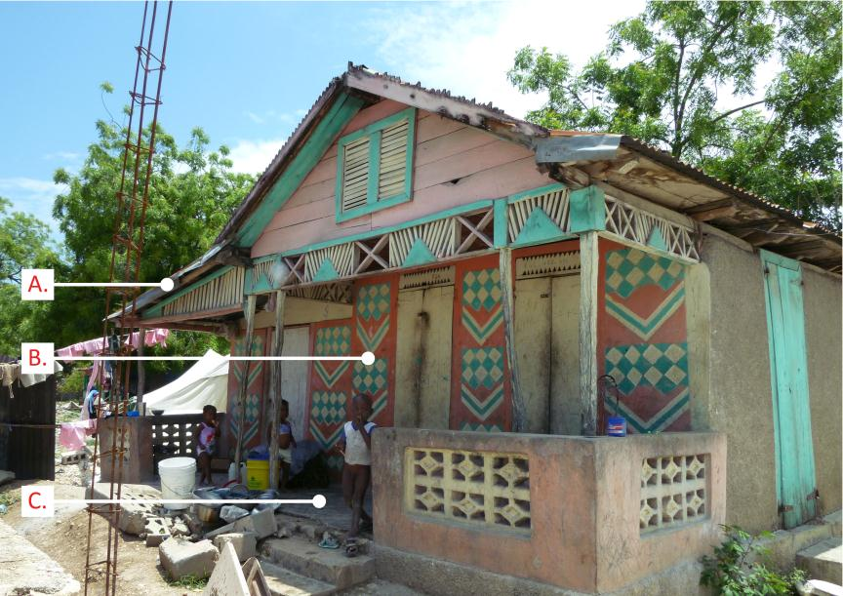

In the rural areas, spatial configuration of villages is based on social structures such extended families. Reinforcing the social cohesion is a shared yard, in Creole called ‘lakou’. More than the buildings that surround the Lakou, it is the communal space that is the real home of those who live there. Functions and amenities of a lakou are shared, such as kitchen area, storage, workspace, bathroom, toilets, and graveyard.

The lakou also occurs in towns and cities. Often it is only recognizable in the interior of a walled block inhabited by an extended family. But it can also emerge in a more public setting, for instance in the shape of intimately connected houses on scaled street spaces.

***<Image 7.x>Rural way of shared living in a so-called Lakou***

***Source; Group 5, Sequin, aux Figuieres, Haïti, 120310***

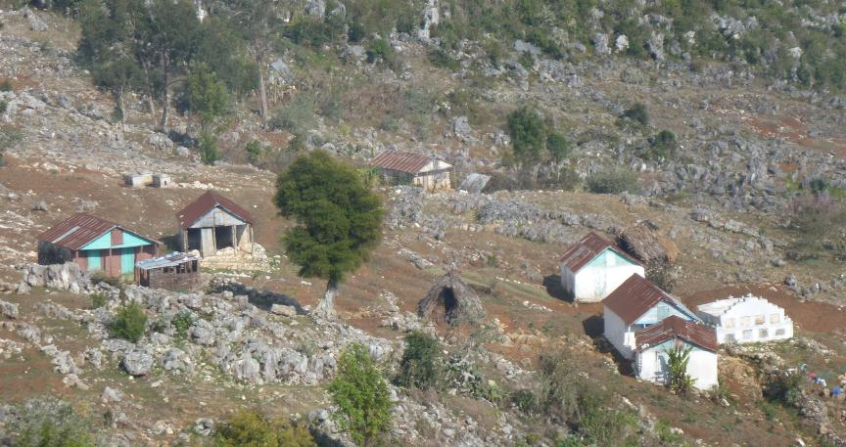

**2.2 T-Shelter Design**

Working with the community Cordaid deployed a pilot scheme of 150 Transitional Shelters across the selected rural areas. The design of the shelter in this pilot phase followed the standards developed by the UN shelter cluster. Amongst others, this prescribed a frame that lasted at least 3 to 5 years and plastic sheeting as facade material. Cordaid’s architects in collaboration with producers and beneficiaries designed the t-shelter n the first month so that distribution and construction of the first 150 T-shelters could be commence in March 2010and completed by end of April.

***<Image 8.x> Transitional Shelter with Plastic sheet for walls.***

***Source; Group 5, Tisous, Carrefour, Haiti, 110501***

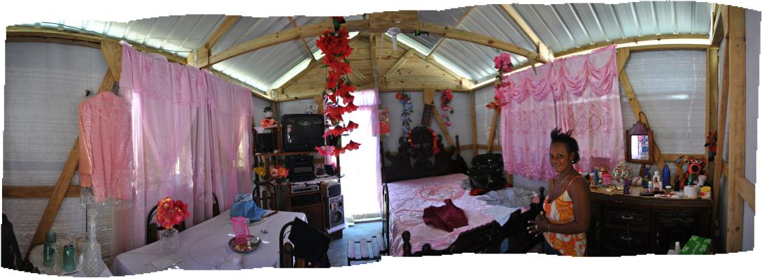

The process of distributing and constructing the initial 150 t-shelters allowed the team to test its methods and procedures. It also demonstrated to the beneficiary communities that Cordaid was committed and able to deliver on its promises. The pilot was furthermore used as the bases to improve the design of the T-shelter. The Community Development and Technical teams came together with the community and began a process of vetting and approving all the elements of the shelter design. Many of the features observed in the Haitian vernacular were incorporated into the final design of the T-shelters core structure. The evolution of the t-shelter assured that the beneficiary would receive a core structure of the highest quality; culturally attuned and flexible to preferences, durable and designed to resist natural disasters in the future.

***<Image 9.x>Vetting and discussing T-shelter design in women focus group***

***Source; Group 5, St Marie, Port au Prince, Haïti, 100827***

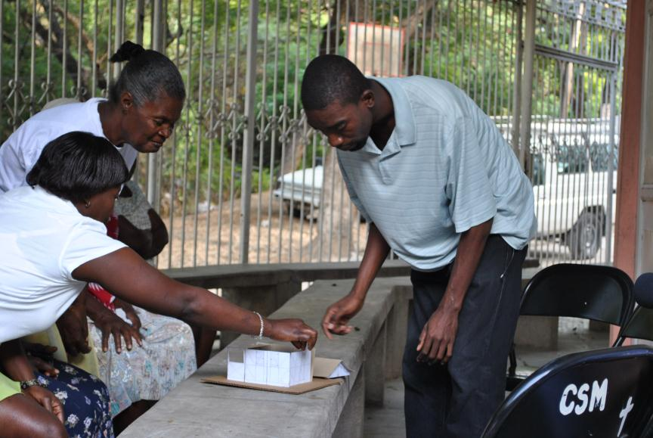

The improved t-shelter design incorporated the following architecture and technical specifications:

* Haitian archetypal elements, such as a porch, two front doors, one back door and a storage space;
* A size fit for a Haitian family, and exceeding the Sphere standard: 18m2 inside (4m x 4.5m) + 5m2 porch + 5m2 storage space above the porch;
* An adapted narrow version of 3 meter wide, specifically designed for tight plots in urban areas such as Grand Goave city;
* Interchangeable standardised elements, allowing for different positioning of windows and doors to be more adaptive to the site conditions in the urban areas and preferences of the beneficiary;
* Increased technical specifications of hardware, such as hurricane profiles and straps, lockable barrel bolts, high standard 26 Gage thick pre-painted roofing sheets;
* High grade and sustainable wood specifications: pre-treated against rot and termites and descendant from sustainable forestry;
* Timber and roofing sheets guaranteed to last for more than 15 years;
* Ready to resist cyclones with wind speeds of up to 108 mph, in accordance with UNOPS requirements; and
* Able to resistant an earthquake up to a magnitude of 7.4.

The success of this design was evidenced in its replication by many other organisations after Cordaid published the technical specifications and drawings. So popular was the shelter that, in beneficiary communities, a sentiment was commonly expressed that ‘Cordaid don’t build T-Shelters, they build Houses!’

***<Image 10.x> T-Shelter core structures literally in transition.***

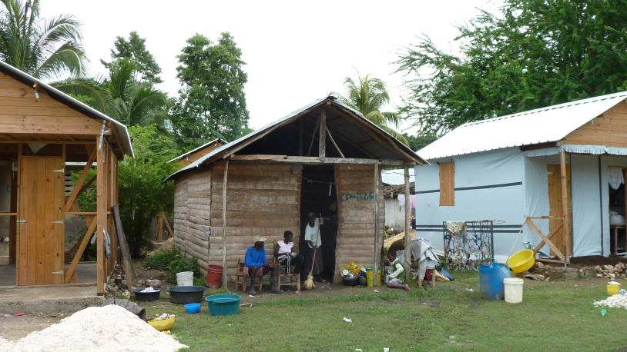***Source; Group 5, Lompre, Leogane, Haiti, 110601***

**2.3 Towards to permanent housing**

In the process of designing t-shelters with the community, the specifications of the Cordaid t-shelter surpassed the minimum standard of the initial transitional shelters developed by the shelter cluster and the Sphere handbook. To ensure that the shelters literally become a transitional roadmap towards permanent housing solutions the timber frame and roofing sheets were specified to last over 15 years. A further challenge in this ambition remained to replace the plastic sheeting as facade material with appropriate wall type solutions.

Based on vernacular systems in Haiti, drawing from experience in Indonesia and in discussion with other NGO’s, Cordaid experimented making prototypes of different types of walls. In the middle of 2010 a model house was built demonstrating more than 11 different façade techniques; from using rubble to bamboo reinforced concrete.

***<Image 11.x> Prototype for façade with 11 samples.***

***Source; Group 5, 7ieme Gerard, Grand Goave, Haiti, 110601***

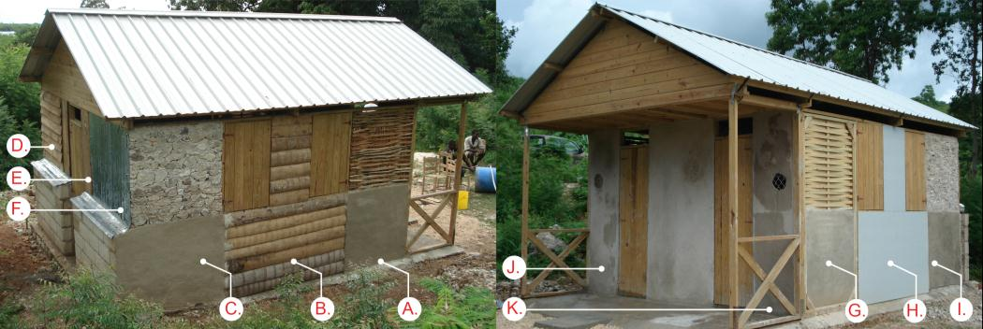

The samples of the wall were rated with vulnerability- and sustainability-criteria which lead to a combined rating. Vulnerability criteria entailed e.g. security, termites, rot, fire-resistance and disaster resistance for earthquakes and cyclones. While sustainability criteria focused on People aspects - e.g. adaptability, maintenance or acceptance, Planet - e.g. material sourcing, eco-load, durability and Profit e.g. how well the local economy could benefit from material and labour sourcing.

The facade samples were then used to calculate bill of quantities, budgets and mostly as a tool for discussion with the community.



***<Image 12.x> Chosen wall typology with vulnerability- and sustainability rating.***

*Source; Group 5, 7ieme Gerard, Grand Goave, Haiti, 110601*

The technique that was selected by Cordaid and the beneficiary communities for the façade of the shelter was a chain-link wire mess wall plastered on both sides with 4 cm thick ferro-cement. With a relatively modern aesthetic of solidity this walling solution spoke of permanence and dignity to the beneficiary communities while its structural properties meant that durability, security, earthquake resistance and longevity were assured. Culturally the ferro-cement walls had the advantage that it allowed homeowner to craft artist ornamentation onto their façade.

***<Image 13.x>Self-modified finished Shelter with ornamentation and rainwater harvesting.***

***Source; Group 5, 7ieme Gerard, Grand Goave, Haiti, 110315***

## 2.4 Implementation

The Neighbourhood Reconstruction Committees performed a large role in the design and pilot phase of the shelters, through it intermediary role with the end users. The next challenge would be to determine where to start with the implementation of a large construction program that would last for the next 28 months. Again the NRC’s took a crucial part in the process of prioritization, mobilization of and communication with the communities.

In accordance with the commitment by Cordaid, households whose house was damaged to the point of being inhabitable, as defined by a red code from the MTPTC, where eligible to receive a shelter. Cordaid established an eligibility list which was shared with the NRCs. The committees then decided on their own vulnerability criteria, with which they prioritized the sequence of the shelter distribution. A procedure for verification was installed to ensure selection for priority was done fairly.

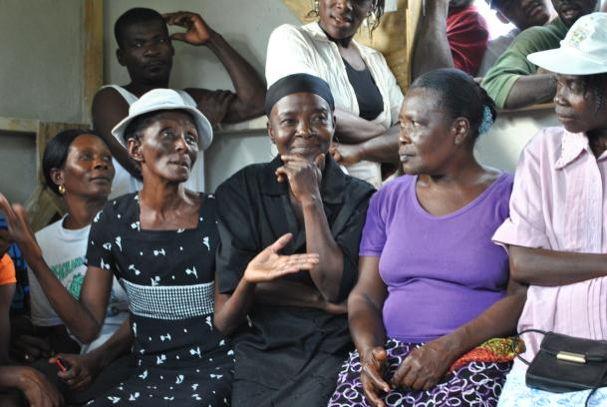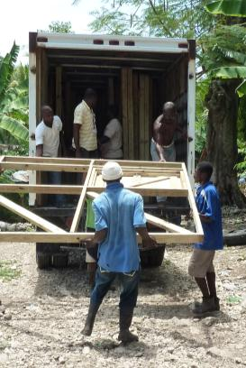***<Image 14.x> Community Driven Shelter***

***Source; Group 5, Lompre, Leogane, Haiti, 100430***

The construction of more than 2,700 shelters poses high demands for procurement, distribution and assembly. Large numbers of suppliers, contractors and partner organisations were selected. Cordaid adopted the principal that anything that could be sourced in country should be sourced in country as long as the production was sustainable and the quality of the products was in line with the set standards. For some materials that criteria could not be fulfilled in Haiti, so that timber for the shelter frame and roofing sheets had to be imported. In that case, Cordaid selected local companies to import the materials. For some procurement, such as timber, the total sum of the contract surpassed a threshold beyond which regulations required an open international tender process. They were allotted to different companies in batches, which were won both by international and Haitian companies. To assure that local capacity was as much utilized Cordaid identified existing timber workshops to produce the frames for the shelters.

***<Image 15.x> Maxima a pre-earthquake coffin and kitchen factory before opening a shelter workshop.***

***Source; Group 5, Port au Prince, Haïti, 100517***

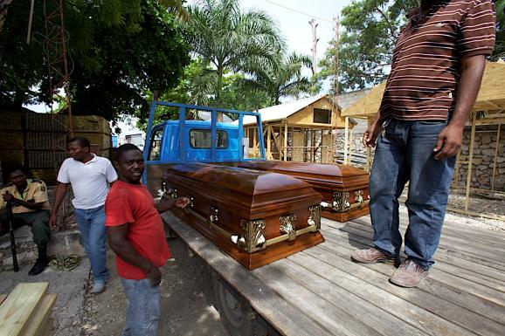

The transport of the shelter frames, roofing sheets and of various locally sourced materials to the beneficiary plots resulted in Cordaid managing a large logistical operation. Up to 400 truck deliveries a month were needed to deliver thousands of m3 of sand, cement and aggregate out onto the field. Hiring a fleet of delivery trucks and signing a selection of local material contractors, was done utilising and promoting the local capacities as much as possible,

Once the kits arrived in the field the frames needed to be assembled. Cordaid partnered with IDEJEN, a local organisation, providing vocational training in carpentry and masonry for young interns’ mainly street kids or school drop-outs. This project gave them the opportunity to gain practical experience. Not only did they provide a skilled workforce to realise the project but also gave Cordaid a chance to invest in local youth capacity, providing the contractors of tomorrow an education in “modern” prefabricated building systems as well as engineering knowledge of earthquake and cyclone proof construction techniques.

***<Image 16.x>Idejen youth interns busy assembling the pre-fabricated elements of the core-structure in the field.***

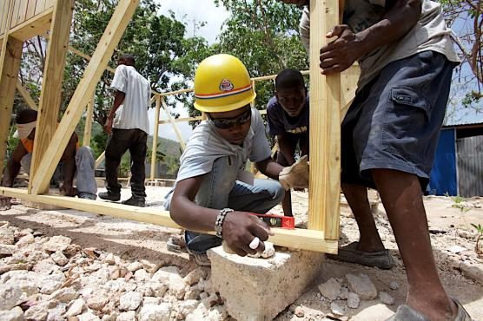***Source; Group 5, 7ieme Gerard, Grand Goave, Haiti, 100517***

The last step of the construction process was the production of floors and walls of the T-shelter. As these did not constitute a structurally critical element, they needed less quality control and supervision. Recruiting local masons and builders became an opportunity that quickly turned into a full-fledged work program. Local entrepreneur masonries and carpenters, called ‘bosses’ were provided a three day training course by an international non-profit engineering organisation, Build Change. The training was tailored to the needs of the program and participants were certified. Managing quality control and contracts across a workforce of more than 200 local bosses, the rural shelter program stimulated economic activity and raised local construction capacity.

***<Image 17.x> Local contractors busy finishing the shelters with the permanent ferro-cement walls.***

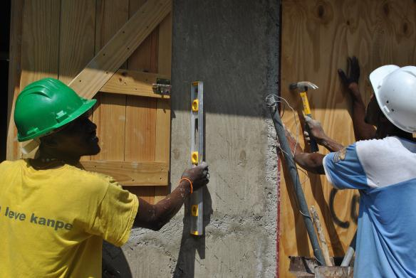***Source; Group 5, Port au Prince, Haïti, 100517***

***<Image 18.x> Finished and inhabited T-shelter.***

***Source; Group 5, Port au Prince, Haiti, 110215 and Chris Kaput, Grand Goave 110804***

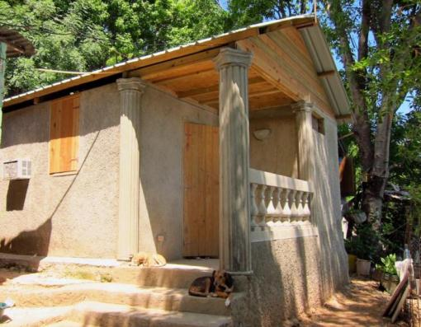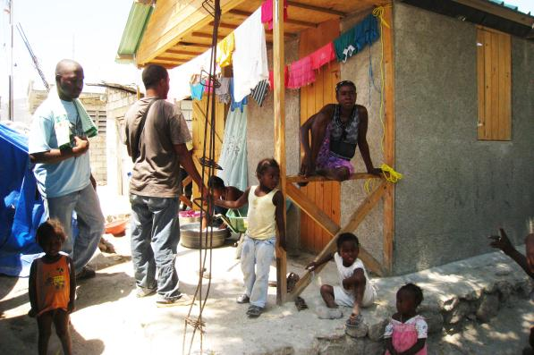

## 2.5 Summary

As part of the rural shelter program a total of 3,320 shelters was built assuring that 18,000 beneficiaries received a roof over their head. In terms of its set commitment of servicing all households with a red coded house, 85 percent of its goal was met. The large number of shelters, and the vast area where they were constructed, has required an enormous and continuous emphasis on streamlining an efficient production process. This has meant a considerable emphasis on logistical management, electronic handling of data, and contract management.

Throughout the program much support was received from the local Neighbourhood Reconstruction Committees, which in turn benefitted from Cordaid’s capacity building initiatives and the experience gained in the process. The successful collaboration also resulted in a shelter design that met all pre-conceived standards while also offering the transition to permanent housing in the rural context. At the same time, Cordaid did not manage to effectively involve those local partner organisations with which relations existed prior to the earthquake. They lacked expertise in disaster relief programming. An attempt was made to involve two partner organisations with the mapping of local stakeholders and beneficiary selection. The outcome was disappointing and the approach abandoned, as the concepts were not familiar and the capacity for accompanying from the side of Cordaid insufficient.

The rural shelter program was not very successful in attracting partnerships with organisations that could complement the shelter construction component with -for instance- water, sanitation and health components. It has been the goal to bring together the disciplines that would constitute a comprehensive village/neighbourhood upgrading. There was more success in finding co-financing partners for the elements already under implementation. In an early stage, 600 t-shelters were built in collaboration with CARE, where Cordaid provided the materials, and construction was done by CARE. CRS contributed to the funding for 1850 shelter frames. Towards the en of the project, Caritas Australia co-financed the building of 120 more shelters.

The involvement of local suppliers and producers of materials, workshops for assembling, drivers, bosses, and construction workers has meant a considerable injection into the local economy. Combined with an investment in the capacity to build according to cyclone and earthquake proof standards has resulted in an improvement of the livelihoods of those working in construction, as well as contributing to better building practices.

# 3 THE URBAN SHELTER PROJECT

Preparations for the urban shelter program got underway after the first assessments had been done and it became clear that areas that were already serviced by Cordaid partner organisations were hard hit. In Port au Prince the program included Villa Rosa and Saint Marie and in the adjoining municipality of Carrefour the neighbourhoods of Tisous and Nan Cocteau were selected. However, the context of these urban neighbourhoods posed challenges that delayed the implementation for months. By the time the program took off in the urban area much knowledge was already accumulated in the rural project.

## 3.1 Context and Culture

Living conditions in the disadvantaged urban areas in Haiti were amongst the worst in the Americas long before the earthquake. From the 1980’s the urbanisation of Haiti increased dramatically to an estimated 3 million people living in the metropolitan area of Port au Prince. With so many people moving rapidly into Port au Prince, the need for shelter, basic services and markets increased. The provision of basic services could not keep up with the rate of urbanisation, and public services deteriorated rapidly. Chaotic urbanisation took place illegally on dangerous lands resulting in high-density slum areas with 80% of the urban population living on 20% of the land[4]. More than half of the informal settlements in Port au Prince are located in high risk zones -steep slopes prone to land slide risks and often classified as no-build zones with a slope >35%, or located in ravines and gullies thus susceptible to inundation. The absence of proper drainage systems in these self-built neighbourhoods causes great danger during rains i.e. landslides and flooding of lower areas. Flooding is also the main threat for those who reside on wetland areas close to the sea. Less than 50% of the urban population has access to water and sanitation, while solid waste collection is absent in the majority of bidonvilles affecting the health of the population. The high density and the absence of a circulation plan/road-footpath system make provision of services such as water, electricity and garbage collection difficult to realize. Government housing schemes failed to supply adequate housing, especially for the poor, who built their own dwellings, occupying or renting private or state owned land. Of the “bidonville” inhabitants over 90% have no formal land titles, due to various causes such as absence of proper land market for low-income people, absence of functioning cadastre and an incomplete civil registry.

***<Image 19.x>View of the bidonville landscape of Port au Prince,***

***Source; Group 5, Logement Jalousie, Port au Prince, Haiti, 110620***

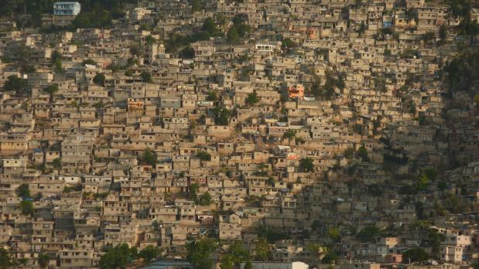

The earthquake destroyed or severely damaged residential houses, public buildings, such as health facilities and schools and infrastructure, including electricity and water, at an enormous scale. Especially the bidonvilles were hard hit, as the homeowners and the local builders lacked the knowledge for earthquake resistant construction, because of the low quality building materials and because of the absence of any quality control mechanisms. MTPTC evaluated 382,256 buildings in Port au Prince; 54% was marked “green” and thus “safe”; 99,403 “yellow” indicating substantial damaged but repairable; and 77,674 tagged “red”, meaning un-inhabitable and unsafe to enter.

***<Image 20.x>Very high damage of the building stock in Port au Prince after the earthquake.***

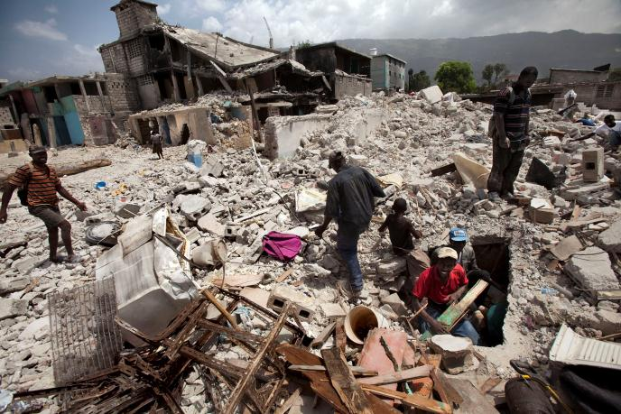***Source; Group 5, downtown, Port au Prince, Haiti, 100305***

In any third world country improving the living conditions in slums is complex due their legal status, absence of planning, weak infrastructure and services and takes many years. With the shock of the earthquake there was an immediate challenge to find quick housing solutions to those affected by the earthquake as well as to link this to a long-term urban development strategy. As there had been no other earthquake in a metropolitan area in recent years, experience from an urban disaster were absent. Furthermore the Government -also gravely affected by the earthquake, was not able to provide direction, since their capacities were already weak and was preparing for the presidential elections planned for the end of 2010.

The initial response was the establishment of camps -both spontaneous and planned, accommodating between 1.3 and 1,6 million people. An early plan to resettle people in new to be developed housing areas 15 km outside town was abandoned. By mid 2010 the Government strategy was to create the conditions for the safe return of the earthquake affected people to their original neighbourhoods, where various international agencies offered to build transitional shelters and a few to repair or retrofit damaged houses. The presence of rubble was a major obstacle, causing huge delays to both these approaches.

***<Image 21.x>Two strategies of planned resettlement and safe return to neighbourhoods.***

***Source; Group 5, Canaan and Villa Rosa, Port au Prince, Haiti, 100305 and 110821***

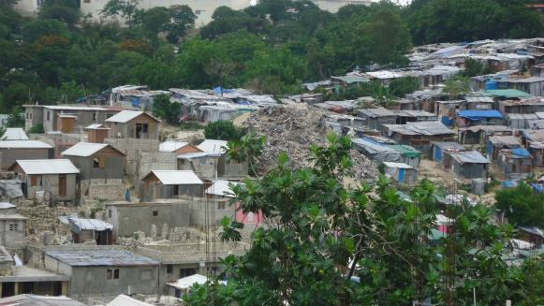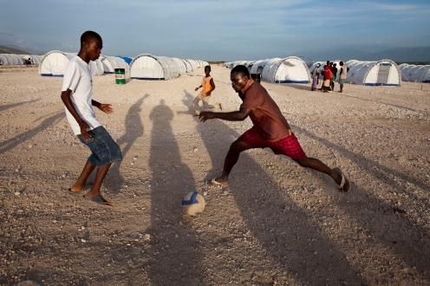

The UN “Early Recovery” cluster promoted long-term strategies such as building government capacity for urban planning and setting the conditions for people to improve their housing and living conditions. This developmental approach takes time and first implementation could only be noticed by the end of 2011. However, the majority of international agencies that came in after the earthquake had a short-term emergency aid mandate, and most left within two years.

**3.2 Adapting Urban Shelters**

The Urban Shelter Project that Cordaid approved by October 2010 recognized the need to incorporate developmental elements to the emergency intervention. Adopting a broad definition of shelter, the objectives included, in addition to shelter, Water, Sanitation and Health (WaSH), neighbourhood improvements such as retaining walls and drainage, livelihoods, community development and social protection.

In line with the Government and Shelter Cluster approach, Cordaid commenced with an urban shelter program, drawing upon the lessons learned in the rural areas. The delays in the urban programme also had its gains; gathering information in the form of technical en social assessments and mapping exercises and a start was made with removal of debris. In the urban areas the sizes of plots the plots were often too small, or shaped in irregular angles, as to allow for the construction of a t-shelter that was designed in the rural program. Consequently, the rural design was technically adopted to better meet the urban requirements. The panels for doors and windows were made the same size and interchangeable and to accommodate narrow plots, a shelter with a width of 3 meter was developed. This resulted in a range of shelters from 12 to 23 m2, while doors and windows could be located at appropriate places meeting the site specific demands.

***<Image 22.x> Shelter in the Urban Area***

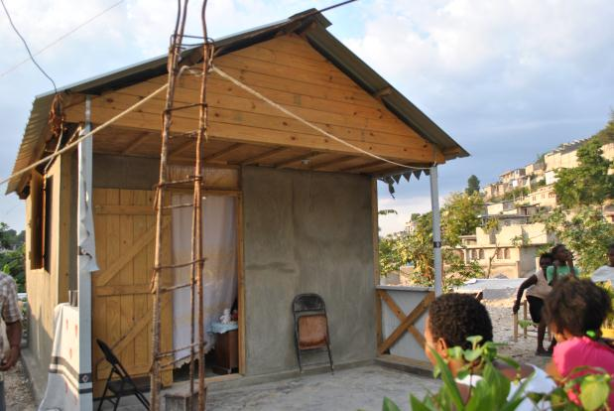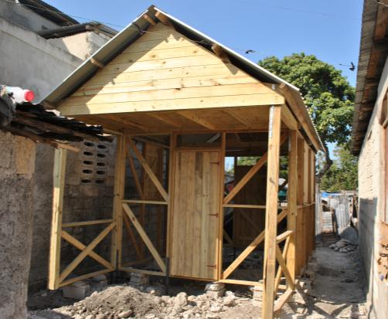***Source; Group 5, Tisous, Carrefour, 110215***

While the t-shelter design had been hailed as a close to permanent solution for the rural and semi urban areas, they often proved to be inappropriate as a long-term housing solution for dense urban neighborhoods. The shelters are “stand alone” structures, cannot be extended upward, and like any pre-designed house cannot properly be located on the often small and odd-sized plots. Soon it was realized that the urban shelter program was force fitting an approach and was not serving the complex urban reality. New strategies were needed. Nevertheless, Cordaid constructed 850 shelters in the metropolitan area of Port au Prince in 2011, using a similar implementation method as described in the rural shelter section.

***<Image 23.x> Force fitting the shelter approach from the rural program in the urban landscape.***

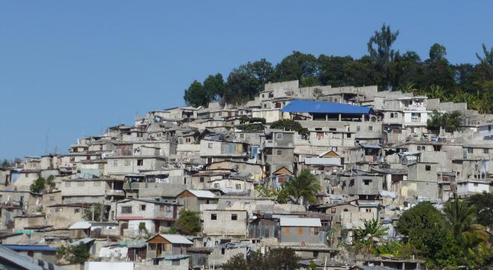***Source; Group 5, Villa Rosa, Port au Prince, Haiti, 120112***

## 3.3 Debris and recycling of materials.

One of the preconditions for construction of houses and infrastructure was the removal or re-use of rubble. Immediately after the earthquake a number of rubble removal and demolition operations started. Cordaid collaborated with two programs implemented by CHF, financially contributing to the labour components and coordinating the activities in the neighbourhoods where Cordaid was active. Villa Rosa and Sainte Marie were cleaned up by June 2012: 196 Houses were demolished and in total an estimated 5,000 m3 of debris was removed.

Demolition and rubble removal was extremely labour intensive, since only 1.5% of the houses could be demolished with heavy equipment. The rest had to be demolished and the rubble carried away manually. The program included cash for work program that paid almost USD 40,000 paid in wages, equivalent to 5,000 labour days.

***<Image 25.x> Manual rubble removal in partnership with CHF.***

***Source; Group 5, Villa Rosa Port au Prince, Haiti, 110825***

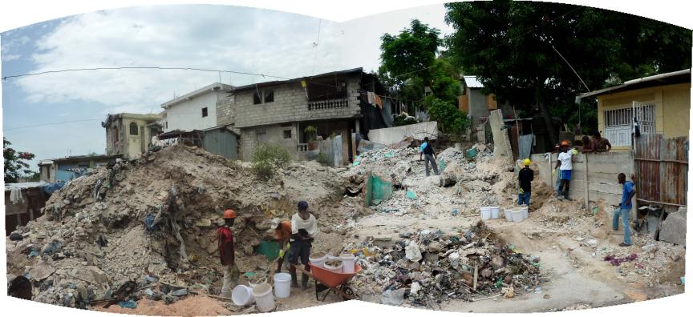

In Tisous, Villa Rosa and Saint Marie the possibilities of re-using rubble from the damaged housing was explored. In general, much of the rubble originated from bad quality housing materials, which did not lend itself for re-use as construction material. An awareness campaign was organized to advocate safe building practices, and attention was given to the risks of recycling materials and as well as practical guidance on possibilities of reuse. Rubble can be used as backfill, but not for construction material. Salvageable doors, windows and roofing sheets can often be used without risk. Compacted rubble was used as backfill under floors in all t-shelters built. A number of initiatives were undertaken to explore the possibilities to recycle rubble for block making. The challenges proved to be difficult -technically especially, since rubble has a low grade while safe construction demands high quality material physics.

***<Image 26.x>Flyer of the awareness campaign concerning reuse and recycling of materials.***

***Source; Cordaid Haiti, Port au Prince, Haiti, 120213****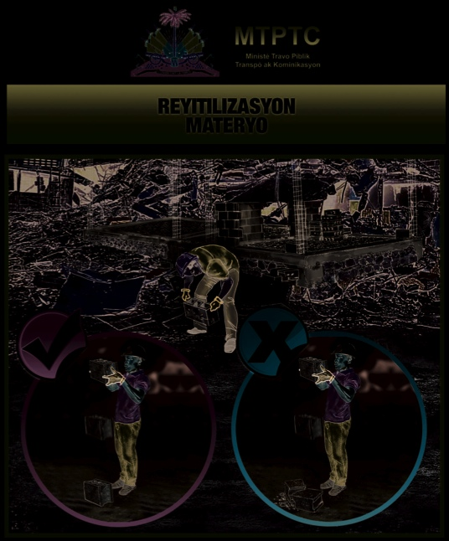*

## 3.4 Repairing and Retrofitting

As the international emergency efforts to build t-shelters were slow to start, and as permanent construction programs were limited to a few selected areas, many Haitians took control and started haphazardly repairing and rebuilding houses themselves. Without the assets to access quality building materials and without knowledge of seismically resistant construction, families were setting themselves up for a repeated disaster in case of another earthquake or hurricane. Similarly, repairs undertaken in risk zones, such as slopes or ravines, without proper mitigation measures, such as drainage and retaining walls, would not leave these families any more resilient for future disasters.

Recognizing the need to develop a better housing strategy for the urban landscape than was offered through the construction of t-shelters, the shelter program explored ways of assisting beneficiaries in ways to repair and retrofit their damaged houses. By retrofitting, a house is made structurally sound and safe, which goes beyond repair as this may return a house to its unsafe condition. By the end of 2010 *MTPTC* officially launched their technical guidelines. By mid-2011 Cordaid signed an agreement with Fondation Architect d’Urgence (FAU) to repair and retrofit houses in Saint Marie, Nan Cocteau and Grand Goave city. As part of this strategy, FAU trained builders, made the design for the intervention, assessed technical requirements, procured the materials, contracted bosses and supervised construction. A total of 850 families were assisted through the house repair and retrofit approach.

***<Image 24.x> Repairs on going in partnership with FAU.***

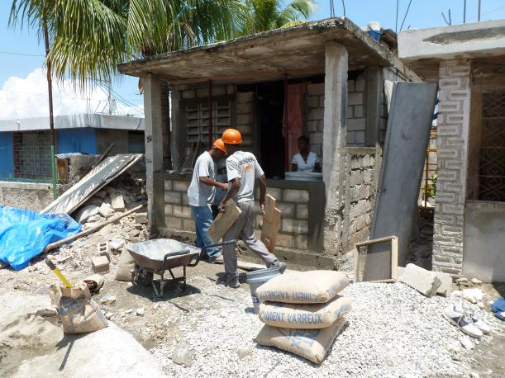***Source; Group 5, Nan Cocteau, Carrefour, Haiti, 120410***

## 3.5 Integrated Neighbourhood Approach

In the summer of 2011, the Government of Haiti launched a campaign in which it advocated the return of internally displaced people to their original neighborhoods. Incentives i.e. rental subsidies were provided for people to vacate the camp sites, while international organizations were lobbied to abandon the emergency phase and start with more permanent housing solutions.

The Cordaid urban shelter program responded by adapting its strategy from t-shelter towards permanent housing and support for neighbourhood improvements. The strategy comprised two main pillars: Owner Driving Housing (ODH) to address the housing needs and an Integrated Neighbourhood Approach (INA) to create the opportunity for the inhabitants to an improved neighbourhood.

The earthquake destroyed over 50% of the houses in many *bidonvilles* and provided the opportunities for re-planning, regularising and formalizing. Secondary effects of these opportunities are improving livelihoods and knowledge related to the building sector. Right from the start Cordaid had built in the objectives in the shelter program to pursue these goals. The introduction of the INA strategy meant that Cordaid diverted budget for shelter construction towards funding a broader range of interventions, albeit on a small scale. The physical implementation of this strategy became known as the ‘initial zones’, which consisted of 100 households in Villa Rosa and in 100 in Tisous.

The INA builds on the existing urban fabric and community’s ability to organize itself towards a common goal. It continued making use of the CAP methodology, through which Neighbourhood Reconstruction Committees (NRCs) were already formed. These community platforms were challenged to plan, improve, prioritize and implement interventions in their neighbourhoods, with technical and financial assistance from Cordaid and its partners. In Villa Rosa and Sainte Marie (Port au Prince) a partnership was formed with Architecture for Humanity (AfH) and in Tisous (Carrefour) a partnership was formed with Architect d’Urgence (FAU) to undertake the neighbourhood planning exercise, each neighbourhood covering approximately 10,000 people.

***<Image 33.x> Elected Neighborhood Reconstruction Committee also the community platform***

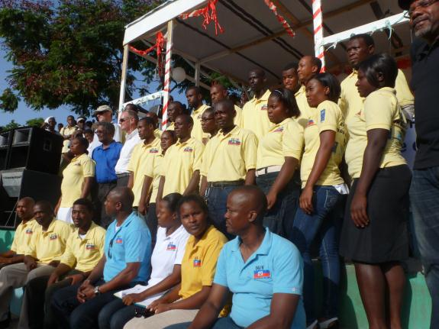***Source; AfH, Villa Rosa,Port au Prince, Haiti, 120416***

Together with the NRC’s and the communities a participative process through focus-groups and workshops was organized addressing and mapping the different elements of a neighborhood. Topics assessed are i.e. risk mapping, housing, infrastructural planning, waste-management, Water Sanitation Hygiene (WaSH) or drainage.

***<Image 34.x> Focus group that discusses the waste management in the neighborhood.***

***Source; AfH, Villa Rosa,Port au Prince, Haiti, 120416***

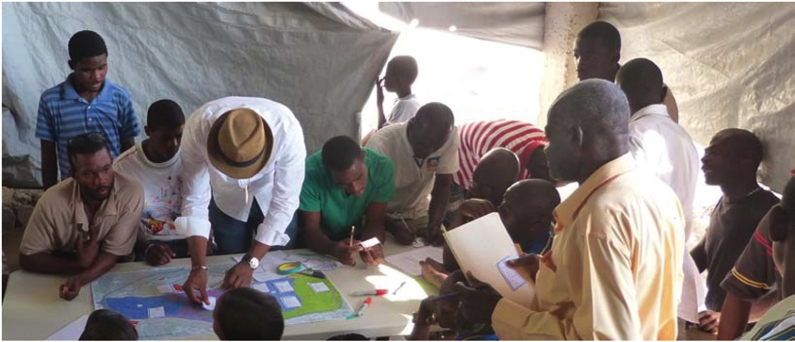

The result of the CAP process is summarized in an urban development plan with prioritized and formulated proposals for funding of neighborhood improvement interventions. These are presented and validated by the community and the local authorities to be broadly supported. The outcome is a roadmap for long term development and supports the community in promoting and advocating for their desired neighborhood with donors and government.

In an ideal world, neighborhood planning takes place before implementation. However, proper participative planning takes time, (often over a year, while the need for immediate action for reconstruction after a disaster is evident. This resulted in house (re) construction before the neighborhood plans were completed or validated. To avoid that new construction would block future developments i.e. interfere with roads, drainages or would be built in risk zones, the urban planners (AFH and FAU) “released” those parts of the neighborhood where new constructions were unlikely to interfere with the new urban plan.

***<Image 35.x> Combined result map of the CAP of Tisous summarizing the different prioritized neighborhood improvements.***

***Source; FAU, Tisous, Carrefour, Haiti, 121004***

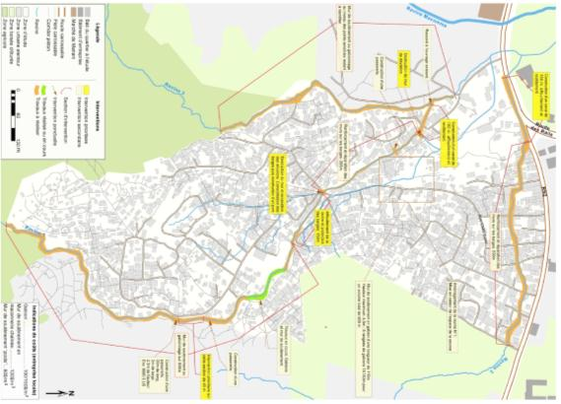

### *The initial phase; Villa Rosa and Tisous*

There is a broad consensus that achieving a reduction in the risk of disasters requires improving neighborhoods from various disciplines simultaneously. However, there is also uncertainty about the quality of the results, the cost and the time needed to reconstruct neighborhoods. The international organizations that responded to the disaster in Haiti came with different perspectives, historical ties, and networks, and under the coordination of the cluster system had spread themselves over the many affected areas. As a result it had proved difficult to bring together the necessary elements of an integrated approach on a large scale. The revision of the strategy by Cordaid created a breakthrough by selecting small zones in Villa Rosa and Tisous, each of approximately 100 households, and being able to put up the funding for complementing expertise. This resulted in several agencies joining their expertise, some contributing their resources, to actually implement an integrated neighborhood improvement plan. The implementation in the initial zones served as a demonstration that such an approach is achievable and replicable city-wide.

***<Image 36.x> Diagram explaining the integration of different sectors with partner landscape.***

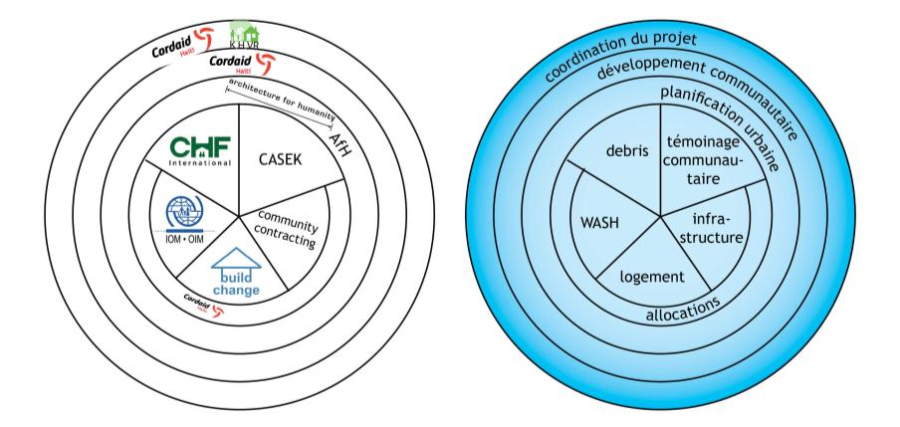***Source; Group 5, Initial Phase in Villa Rosa, Port au Prince, Haiti, 120703***

Priority was given to the development of neighborhood plans for the initial phase. Part of the area was released to allow simultaneously house repair and retrofit. Under the neighborhood reconstruction committee a smaller committee was formed, comprising inhabitants from the demonstration areas. For specific areas, or topics separate focus group discussions were held. The proposals from these groups were fed back to the committee, incorporated in the plan, prioritized and validated by the community, followed by implementation. Toilet constructions (often several families sharing a toilet) were using also an owner driven approach whereby IOM had prepared the designs and Cordaid advised and assisted the beneficiaries during construction. As well as roads, drainage, retaining walls and other small infrastructure works.

***<Image 38.x> Design services and detailed plans were discussed and validated in smaller focus groups.***

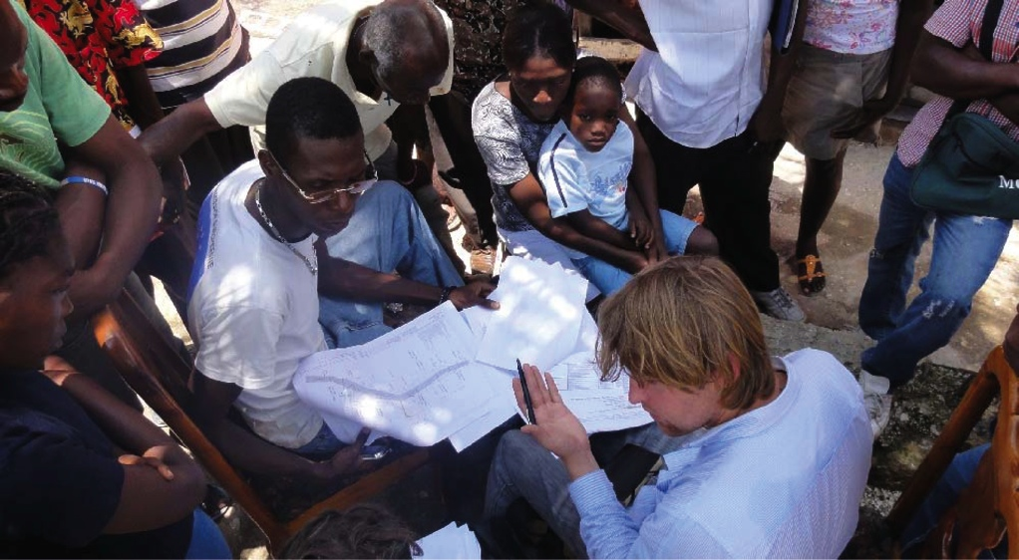***Source; Group 5, Villa Rosa, Port au Prince, Haiti, 121027***

The initial zone that was selected for the demonstration project in Tisous is located on a steep slope (over 35 degrees) above a ravine. Improvements of footpaths, drainage, retaining walls and the protection of the ravine is technically complex. CARE and Cordaid hired a local company to develop the technical plans and tender dossiers. Five companies with sufficient expertise and the necessary equipment are involved in implementation, mainly using local labour under their professional supervision. The total investment was USD 480,000 covering 100 families on a steep slope. If the Ravine works are excluded the amount comes to USD 400,000 or USD 4,000 per family.

***<Image 37.x> Initial phase zone in Tisous of infrastructure. MISSES BEFORE PHOTO***

***Source; Group 5, Tisous, Carrefour, Haiti, 120703***

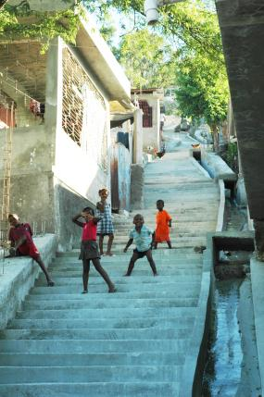

The demonstration area in Villa Rosa is relatively flat and community contracting was used as mode of implementation for footpaths and drains. The inhabitants of one street prepared together with AFH the technical plans, spray-painted location of footpaths, and submitted a proposal for funding to the neighborhood committee and Cordaid. Similar to *ODH* the funds are transferred in tranches to the street representative. The street inhabitants manage the construction i.e. hires local bosses, procure and store materials and supervises the work. AFH engineers guide, assist and signs off for subsequent releases of tranches based on progress and quality of works against the plan and BoQ. This method has worked very well and from its own contribution the inhabitants have added trees, benches etc. (see explanation of the Lakou above). UNOPS provided solar streetlights (also outside initial zone) to improve safety. Another interesting development was the sponsorship by NIKE of the basketball field in this demonstration area. The total funding for the neighborhood improvements of xx meter of footpaths and drainage came to USD 108,000 (or USD 1,000/family), excluding improvements to basketball field (USD 24,000).

***<Image 38.x> Initial phase zone in Villa Rosa with implemented community infrastructure.***

***Source; Group 5, Villa Rosa, Port au Prince, Haiti, 120703***

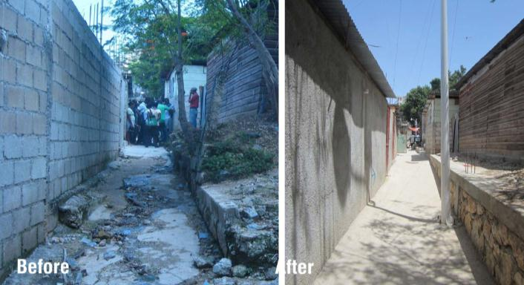

In the initial zones public interventions have been implemented, while XX projects are awaiting funding of which a number has been committed i.e. In Villa Rosa, street lighting by UNOPS, water supply improvements by ACF. Through this approach local authorities, service providers and community representatives were brought together thereby contributing to bridging the gap of mistrust between “bidonville” communities and local authorities.

## 3.6 Owner Driven Housing

The *ODH* strategy stimulates safe construction through awareness campaigns, knowledge transfers, monitoring quality of building and materials, and access to funding. It builds on existing pre-earthquake systems, people resources, knowledge and ambitions for reconstruction. The strategy recognizes that there is no standardized end product; houses will be built based on available space and funds, extended, improved and changed over time depending on needs and means. Due to urban density, upward expansion of houses must be taken into account.

Technical assistance and funding in the form of grants were made available by Cordaid, conditional to obtaining a grant and/or loan was that the house must be safe and must fit within the neighbourhood plan. Cordaid provided design, training and supervision services to the beneficiaries with assistance from Cordaid’s partner organisation Build Change. The ODH programme comprising 1,300 retrofits and new built houses covered the whole area of Tisous and Villa Rosa, each with approximately 2,000 families.

The majority of expenditures happened at neighbourhood level and ensured multi-times turnover of the grant within the community, and therefore generates and strengthens economic activity around construction and peripheral activities.

***<Image 27.x> Knowledge transfer to builders during a training sessionin partnership with Build Change***

***Source; Build Change, Villa Rosa, Haiti, 120416***

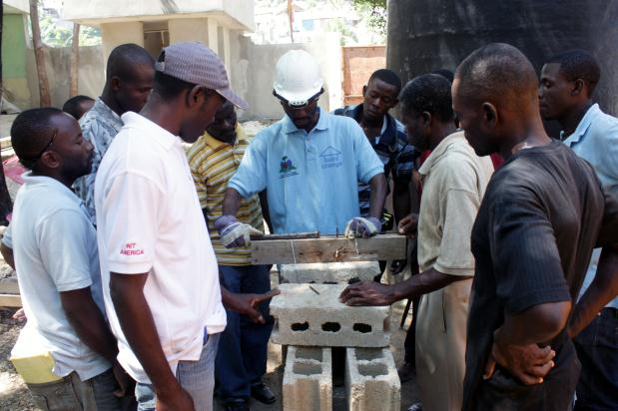

***Training and awareness***

As part of the owner driven approach, the project stimulated and facilitated appropriate and safe building practices for the self-building of houses in the earthquake affected urban areas. It invested in upgrading knowledge and skills of the home-owners and builders involved in the construction process. It contributed into changing construction practice permanently so that homeowners will build safe houses now and in the future. So rather than directly building houses for people or providing building materials, it comprised in explaining and training in safe design and construction.

Together with *MTPTC* key messages for the awareness campaign were developed for different aspects of the building process; this included e.g. the (re)use of quality materials, building essentials for future expansion and low or no cost improvements to existing common and culturally preferred ways of building practice.

Different actors involved in the construction of neighbourhoods received specific applicable knowledge and levels of information. The dissemination of the key-messages happened in different forms; material suppliers like block makers were offered trainings in quality and business management, builders received a three day training program and received constant monitoring during the construction, the beneficiaries of the *ODH* program received individual supportive training in e.g. budgeting or procurement and received a construction manual, other inhabitants of the neighbourhood were targeted with simple key-messages in cultural events or by poster and flyers spread through their neighbourhoods hotspots like churches or local bars.

***<Image 28x> Home-owner awareness training with the construction manual.***

***Source; Build Change, Port au Prince, Haiti, 120213***

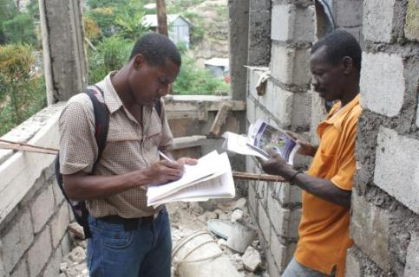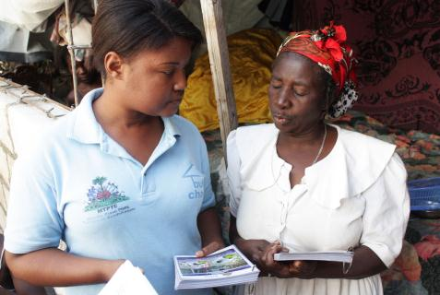

Cordaid set-up community resources centre (*CRC*) in the neighbourhoods called Houses of Knowledge (*HoK*). The GoH department responsible for the long-term reconstruction the *UCLBP* (Unité de Construction de Logements et Bâtiments Public) formalized the set-up of these *CRC*’s nationwide in their strategic vision[5] to facilitate bottom-up dissemination of building knowledge.

In the *HoK*’s trainings were held for home-owners and builders, technical resources en consultancy hours for good building practice were made available and mock-up models of good & bad quality materials and construction are displayed. The *HoK*’s are managed by the *NRC* who uses this space also for their community meetings.

***<Image 29.x> A training session in the House of Knowledge about quality of materials***

***Source; Build Change, Villa Rosa, Haiti, 120316***

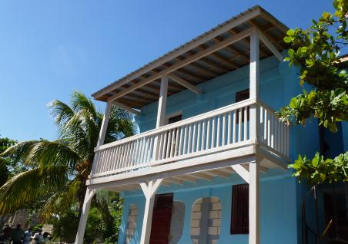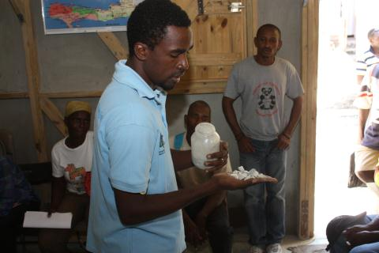

The results of this effort and investment for now and the future are better equipped builders to construct safe houses as well as increased knowledge with homeowners to design, monitor construction and identify quality materials.

***House construction (retrofit and new build)***

Cordaid has provided technical support to approximately 1,600 families and provided financial grants for 1,300 “yellow” and “red” marked houses.

The grants supported respectively $1,500 for a yellow retrofit and $3,500 for a red retrofit or a new house construction. Retrofitting is a technical term that not only repairs -but also structurally improves, a house.

***<Image 30.x> Retrofitting a Yellow tagged house with Owner Driven Reconstruction***

***Source; Group5, Tisous, Haiti, 12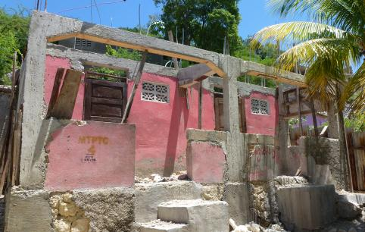0831***

Cordaid’s partner Build Change provided technical assistance to beneficiaries and prepared retrofit plans and new house designs. These were calculated using the *MTPTC* guidelines and ensuring to accommodate safe future expansion, especially in the form of a second story.

Work comprised discussions with the individual beneficiaries on technical requirements for safe construction; design based on needs, detailed drawings and a bill of quantities with a material list and cost estimate. In case a design service exceeded the grant amount available, contributions by beneficiaries were stimulated and/or reduction of the scope of works was established together with the beneficiary. After the design service was delivered, the beneficiary applied to Cordaid for a grant through the *NRC*’s. If all criteria were fulfilled, funds were made available and released in three tranches to the beneficiary. The beneficiary was responsible to purchase the materials, hiring a trained builder and manage the works. Build Change engineers assisted the beneficiary in quality control and on-site training & monitoring of builders.

A remarkable outcome was that 60% of the red marked houses could be retrofitted within the grant amount and therefore resulting in double the “safe” floor area compared to new construction.

***<Image 31.x> An owner driven retrofitted Red tagged house combined with new second story construction.***

***Source; Group5, Villa Rosa, Haiti, 120831***

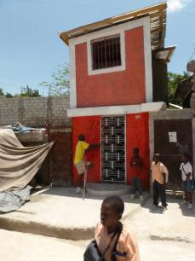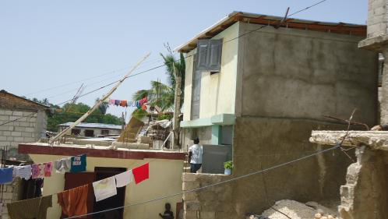

The “owner driven” approach was also successfully applied to the construction of toilets for 200 families in the demonstration areas (see below) and the construction of retaining walls for over a 100 families to ensure the site and foundations of the houses are safe and durable.

***<Image 31.x>Owner driven Sanitation and Retaining Walls under construction.***

***Source; Group5, Villa Rosa, Haiti, 120831***

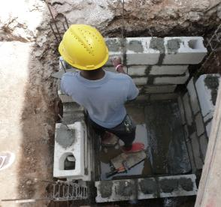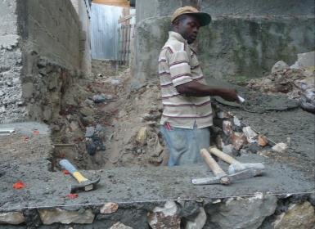

## 3.7 Social Protection

Part of the vulnerability of the bidonville inhabitants is caused by a lack of clarity of tenure. Often the inhabitants have settled informally, especially on the outskirts of the cities. Not having a title to the land can be a major discouragement from investing in proper construction of a house, as eviction remains a threat. Without formal habitat status, it is also much harder to access public services adding to their vulnerability. Therefore land tenure can be a crucial component for neighbourhood improvement. The issue is complex and a solution is not readily available. The social protection component of the shelter program took shape through a two pronged approach. On the one hand Cordaid collaborated with the UN clusters and with UN Habitat that approached the land right issue from an academic judicial perspective. On the other hand Cordaid went along with locally established practices of land use wherever this was not in the way of a long term solution. Sometimes these two perspectives could not be reconciled and a choice was made on the safe side. For instance, working in the densely populated urban areas, our governmental partners insisted that no permanent construction could take place closer than 10 meters from ravines or on slopes of more than 35 degrees. Households with spots in these dangerous zones were not eligible for the program of new construction. At other times these two perspectives coincided, for instance when the government announced its policy of ‘status quo ante’. This policy meant that households could be served by the shelter program, even without holding land titles, but based on community testimonies of their presence prior to the earthquake. The main activities:

* The rural and urban shelter program accepted both house owners as tenants as beneficiaries of a shelter. Cordaid facilitated the signing of contracts between the house owners and their tenants, in which – amongst others - an agreement was included not to increase rent for the next three years.
* All recipients of a shelter received a certificate, which was co-signed by the municipality. While not granting the title to the land, it assured temporary use of it for three years. In the long run, having a written document asserting ones presence on a plot of land can make the difference, as becomes clear in the next point.
* The Haitian law provides an article that - under certain conditions - may grant land rights to people that can prove that they occupied a plot for longer than 20 years. Cordaid worked together with the local authority (CASEC) to test the possibilities provided by this law. Community testimonies were prepared for a first group of 20 beneficiaries. The CASEC provided certificates in acknowledgement of receipt of their cases, whereas the decision will have to come from the municipal level.
* Cordaid also facilitated the creation of community testimonies, certifying that beneficiaries that joined the new house program were already living on a certain plot at the time of the earthquake. This approach followed a policy of the government to encourage inhabitants of refugee camps return to their neighbourhoods, which was promoted from July 2011 onwards. It signalled an acceptance of the situation at the time the earthquake struck and it became known as the ‘status quo ante’. Cordaid collaborated with UN Habitat in improving the formulation of the status quo ante document that was given to beneficiaries.

***<Image 36.x> Squatters and renters in a camp with on the foreground T-Shelters. / A signed copy of a community testimony.***

***Source; Group5, Villa Rosa, Haiti, 120112 / 111111***

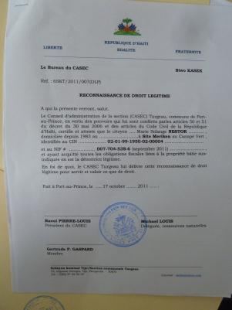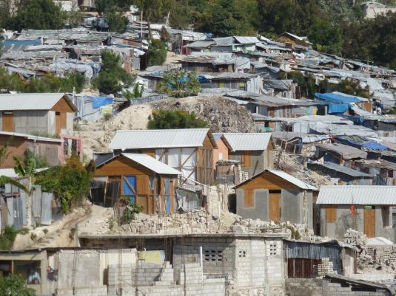

## 3.8 Social Capital Development

From the initial start, the construction and repair of houses has involved local communities in designing the approach, prioritization of vulnerable households and communication with beneficiaries. The urban planning needs for WASH activities and neighbourhood infrastructure has relied heavily on the participation of beneficiaries through committees of representatives. Furthermore, the efforts of improving land tenure involved organizing the community around interest groups that can act together in dialogue with local authorities.

The component of strengthening the capacities of local communities was started with an intensive CAP processes, out of which were formed Neighbourhood Reconstruction Committees. Cordaid has a long tradition in participatory processes to emancipate and empower civil society groups. In this respect it may have come as a surprise that the CAP methodology was selected above the in-house developed methodology of IDOD (Institutional Development and Organisational Development). The CAP methodology, which was introduced by the community development expert that was recruited, was well known in Haiti and could have well fulfilled its purpose. At the same time it is an indication that there was insufficient expertise of the Cordaid approach on board of the team, and it may have meant that at a more detailed level the lesson learned in Indonesia by Cordaid was not heeded. A criticism can be made that the process of strengthening the existing social structures started targeting the disaster struck communities. From these, representatives were drawn to take part in focus groups and committees. However, the recommendation from the previous relief operation was to build on existing civil society which would have required an in-depth analysis of power relations between formal and informal groups. These social structures are not necessarily limited to the area hit by disaster but may require a diagnostic of a wider region. Ultimately, community leaders and board members of CBOs found their way in representative committees that collaborated with Cordaid. But meanwhile it exposed Cordaid to the accusation of initiating and steering community organisations.

The shelter program undertook a genuine effort to strengthen the legitimacy of the Neighbourhood Reconstruction Committees and advocated a representative process. The NRCs of each neighbourhood embarked on a process in which they determined their mandate and changed their name accordingly. The strategy of the shelter program for strengthening social capital varied across the neighbourhoods and comprised of the following elements:

* Specific trainings of skills of members of CBO’s on a broad range of subjects that the CBO’s prioritizes as being of value to their functioning. Subjects included project cycle management, resource management, disaster risk reduction, proposals writing, conflict mediation, alphabetisation and civic education. In the urban areas the trainings were organized by a partner organisation, IHDI. In the rural areas the skills training on *project cycle management* and on *proposals writing* was followed by a small grant project, to which the neighbourhood reconstruction committees applied for funding of 6 small projects. In some of these projects the implementation was jointly undertaken between the NRC and another local CBO.
* Specific communication trainings to empower the committees and CBO members to develop and disseminate clear messages leading to better informed communities on issues affecting the reconstruction of their neighbourhoods. Communication with the members of a neighbourhood was considered of importance to enhance the legitimacy of the NRCs. This component was implemented by a specialized organization, PANOS.
* Organizational strengthening of the NRC’s to facilitate the determination of their mandate and their strategy. It included support to understanding the dynamic environment in which they operate and a vision of their possible role. It furthermore includes knowledge of the relations between laws, local authorities, civil society and civilians. The approach was implemented in urban areas by IHDI. In the two neighbourhoods in Carrefour, the NRCs were supported in their responsibility of running the *House of Knowledge*, which were constructed as demonstration sights for building techniques and which provided a space for staging awareness campaigns at part of the objective of Disaster Risk Reduction.
* Support to the institutional imbedding of the civil society, meaning the relations with authorities, ministerial departments, local and international organisations, as well as community based organisations in the neighbourhoods. In the areas of Villa Rosa and Saint Marie an initiative of a government project called ‘16 quartiers, 6 camps’ implemented by UN Habitat advocated the institution of committees to take a leading role in all developmental aspect relevant to their neighbourhood and act as channels of communication. The earlier formed NRCs stepped up to the plate and were officially validated as ‘plateforme communautaire’. In addition to that, the CASEC, the representative of local authority, pointed to a section of Haitian Law that prescribed the forming of a ‘Comité Developpement Section Communal’ (CDSC) as a body for dialogue on development issues between representations of neighbourhoods and the authority. The formation of NRCs as well as Community Platforms can be considered stepping-stones to that broader vision. A new programme was started in the first half of 2012, in which Cordaid and the CASEC collaborate to realize the creation of the CDSC.

With the withdrawal of Cordaid from the neighbourhoods, the NRCs gradually took on larger responsibilities, especially in the urban areas, such as chairing the bi-weekly coordination meetings. Cordaid transferred as much as possible the knowledge and the data that was collected throughout the shelter program. The committees were equipped with a workstation and all databases and maps that have been generated, often with their collaboration, so that they have the means to interact with both government and international organisations concerning the development of their neighbourhoods. While this meant that at the moment of exit of Cordaid from the stage the committees were in control, it also serves as an indication how long it took to genuinely cede discretionary power to local counterparts.

## 3.9 Livelihoods

The urban shelter program gave a considerable impetus to the construction sectors with all its local material supplies and labour. The impact to livelihood achievements can be quantified indirectly by the injection of funds into the communities where Cordaid works. A sustainable impact to the livelihoods of people is furthermore achieved by the formation of skills of labourers.

The sum of all the Owner Driven Reconstruction Programs have a combined contract value of USD 3,4 million of which over USD 2.1 million has been released to the beneficiaries/home-owners. (outdated data: June 2012) The Urban Shelter Program generated revenue for 318 Bosses and their teams. In the phase of building Shelters, approximately 50 youths have been trained and employed in a partnership with Idejen, an organisation that works with school drop outs between the ages of 15 and 25 ($360,000). The USD 40,000 for rubble removal has been mentioned before.

Through the *ODH* approach 300 builders and 400 unskilled workers have been employed. FAU employ 38 local foreman and approximately 180 unskilled labourers from the area. The CARE/Cordaid infrastructure works carried out by 6 contractors, employed approximately 200 people, the majority from the Tisous. Furthermore, some links have been made with CRS Rubble to Reconstruction (R2R) programme and 4 entrepreneurs from Tisous participate in the programme. The 4 entrepreneurs have received training and materials to operate.

After a televised promotion of the Postcode Lottery in The Netherlands, Cordaid was donated a grant of EUR 25,000 for the implementation of a special project. It was decided to use this grant to rehabilitate the livelihood of successful artisan businesses, in the Neighbourhood of Bel-Air. A partner agreement was signed with Caabel (Coordination Des Artistes et de Artisans du Bel-Air) in December 2011. This association represents 84 members with over 300 employees. The project has realized a Mural of 250mtrs long to give the neighbourhood a distinctive entry and to reconstruct 10 Ateliers.

***<Image 37.x> Livelihood was generated indirectly by the provision of good housing.***

***Source; Group5, Bel-air, Port au Prince, Haiti, 120531***

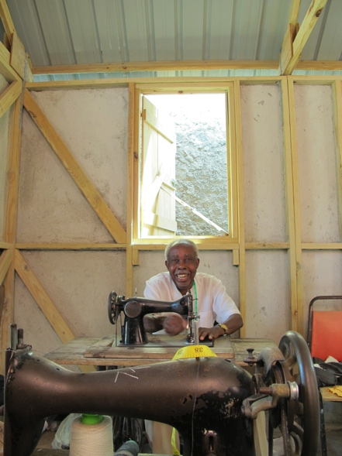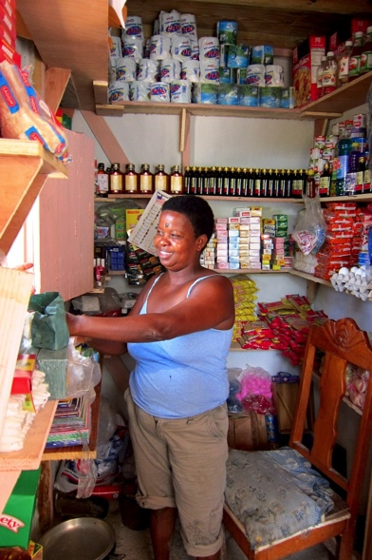

## 3.10 Summary

The urban shelter program was successful in achieving its goals by changing its strategy when required. What started as an emergency program of constructing shelters, developed into a program of behavioural change. At household level and in the sector of construction a different way of building was installed, which will make the communities more resilient to natural disasters.

Forced by the obstacles met in the urban context, the intervention developed from building t-shelters to an owner driven housing process. In this process it turned out that much more houses can be built when owners are empowered to take charge of the construction. The ODH process did away with the need to manage the logistically challenging situation of hundreds of building sites. Interestingly, the positive lessons from the ODH program were immediately applied in other components of the INA, such as owner driven sanitation and community driven infrastructure components.

The integrated neighbourhood approach that was implemented in the initial zones demonstrated the added value of different disciplines reinforcing each other in that it successfully upgraded a neighbourhood and improved the wellbeing of its inhabitants. While it was difficult to attract complementing agencies in the rural shelter program, the experience from the initial zones shows that actors are readily available to join in a collective effort once it can be shown that it can be successful. However, this meant that only on a limited scale the program achieved the broader objectives that were included in the shelter project.

Finally, the urban shelter program has contributed to a community that has become organised and empowered to take charge of the development of its neighbourhood. The representative committees have gained in legitimacy both towards the community they represent as well as local authorities and international agencies. This process of institutional strengthening has come about by performing their role in mobilizing people and coordinating organisations during the project. No amount of training hours in a course environment could have achieved the same. The application of the CAP process has shown the added value of this methodology. But it has also shown that without in depth knowledge of supporting empowerment of civic organisations mistakes can be made.

# 4. Conclusion

The Haiti Shelter program drew on Cordaid’s earlier successful shelter experiences. We learn from each disaster and the Haiti experience feeds Cordaid’s future approach. A disaster in an urban environment was relatively new, especially given the scale of destruction. One of the major steps made in Haiti, compared to earlier responses, has been the effort to Link Relief, to Reconstruction and Development (LRRD). Looking to the future, the Haiti Shelter Program also provides lessons that may contribute to better interventions in case of new disasters. More immediately, the shelter program has yielded knowledge with which follow up interventions in Haiti, can be made stronger.

## 4.1 Shelter design

Beneficiaries, government and other agencies appreciated Cordaid’s transitional shelter design and its adaptations towards creating permanent housing solutions. Key to the success was that the design was based on the traditional architecture, functionally appropriate and made use of local resources and skills. Architects collaborated from an early stage and the development involved the end users in every step of the process, though elaborate vetting sessions. The design was considered open source and shared through the community of the shelter cluster.

*Success factors:*

* *Architects involved in initial design*
* *Continuous validation by end users*
* *Cordaid design treated as open source*
* *Quick start of pilot phase secured trust of community and yielded feedback*
* *Efficient production lines in final phase*

*To be improved/Challenges*

* *Scaling up production brings high demands on logistics and information management, which resulted in long delay of reaching full production speed.*
* *Automated information management to start sooner.*

*Policy implications:*

* *Choice for durable multi-hazard product of high quality, rather than focus on quick numbers.*
* *Cordaid offers added value to emergency operations by taking the lead on design.*

## 4.2 Social Capital

An essential element in the Shelter Program has been the building of social capital through the collaboration with representative neighbourhood committees and using the ‘Community Action Planning’ tool. The CAP process includes a continuous cycle of planning, validation and implementation that allows for an early start of activities. While the CAP process drew on the local communities as resources for planning interventions, the step of mapping the existing civil society groups and their power relations was taken lightly. A communication strategy was essential and included training of staff, key messaging; information and complaint systems, and accountability of committees towards communities. In support thereof, an important success factor has been to invest in a digital data management system. The work on strengthening social capital will continue in an EU “state – non-state actor” program, called Kanape Ve Leve Kanpe (KVLK). Amongst others, it is the ambition of the program of connecting the Community Platforms and connecting these with the local authority. The Haitian law already foresees in such an interface, called the CDSC (Comité Développement Section Communale), but this project would be the first to instate it. In 2012 the GOH started a large scale project with WB funding and with UN implementation partners called *16 Neighborhoods 6 Camps*. One of the neighborhoods picked by this project was the Villa Rosa and Sainte Marie site, which have been part of the Cordaid shelter project. This way, the ‘16/6’ project will benefit from the experience that has been gained and will be able to replicate parts of it in other neighborhoods.

*Success factors:*

* *A comprehensive approach: CAP, laid down in a clear manual (CAP).*
* *Through delivery of the shelter program, the representative committees enhanced their legitimacy*
* *Due attention for communication strategy and messaging towards beneficiaries.*
* *Connecting to existing mechanisms and laws for interaction between state and non state actors.*
* *Through building of social capital communities become resilient to shocks and are able to continue the development efforts of their neighbourhoods in the post emergency phase.*

*To be improved/Challenges*

* *A methodology and manual cannot compensate for insufficient experience in community development.*
* *Weak local organisation of communities (e.g. rural areas) risks becoming overly directive.*
* *Program to adhere to transparent criteria, despite pressure from local actors to accommodate exceptions.*
* *Genuinely ceding discretionary powers to local communities feels at odds with the control needed to meet emergency aid targets.*
* *Sociological expertise needed from an early moment for community development, even during rapid assessment (analysing existing civil society-social mapping).*
* *Accountability towards community, for instance through complaint procedures, was built in only towards the end.*
* *Complex property situation in Sainte Marie, which is owned by the Church, caused delays in genuine inclusion of representative committee.*

*Policy Implications:*

* *CAP approach is valuable asset and needs further development*
* *Building Social Capital is indispensible for Disaster Risk Reduction.*

## 4.3 Integrated Neighbourhood Approach

Disaster risk reduction was already part and parcel of the Cordaid shelter approach, and in Haiti this was emphasized with the slogan ‘building back better’. Relatively new was the way in which it was incorporated in the urban environment Haiti. Much emphasis was given to participative urban planning exercises, community risk mapping, and implementation of prioritised projects. Consequently, it is tied to the process of building social capital mentioned above. Furthermore, Cordaid joined forces with several international organisations to cover a variety of fields of expertise that complemented the components that Cordaid implemented. This strategy meant that the achievement of certain specific objectives was made dependant of partners. In the rural areas it proved harder to find partners with complementary disciplines. In the urban area, there is a much higher potential to collaborate with partners to bring about an integrated approach. However, to make a convincing case for integrated neighbourhood development, Cordaid had to redirect budget that was intended house construction towards funding these partners in small areas that would act as initial zones for the Integrated Neighbourhood Approach.

*Success factors*

* *Complementing disciplines coming together in one neighbourhood lead to Disaster Risk Reduction.*
* *Neighbourhood Committee increasingly ready to take on a coordinating role, gradually replacing Cordaid.*
* *Local authorities firm endorsement of integrated approach.*
* *Urban planning processes did not prevent careful implementation taking place simultaneously.*
* *High quality work by partner organisations.*
* *Lessons from Owner Driven Housing (below) coming available to generate a community driven infrastructure project (Villa Rosa).*

*To be Improved/Challenges*

* *International organisations all come with their own priorities and preferences.*
* *In the rural areas also the international organisations are spread out, with less possibility to join forces.*
* *Cordaid’s longstanding local partner organisations did not possess the complementary disciplines to engage them in the shelter program, to their great dismay.*
* *INA comes with a lengthy preparation process, which is at odds with the ‘pressure on outputs’ usual in an emergency context.*
* *In selecting an initial area as a demonstration phase, the level of complexity must be balanced. For instance, proving the possibilities of building on steep slopes (Tisous) comes at high costs of time and funds.*
* *When contracting complementing organisations a service delivery contract runs into procurement obstacles while a partner agreement reduces the level of authority.*
* *Tendency for urban planning processes to block implementation until a master plan is agreed.*
* *Participative planning processes touch more elements of neighbourhood improvement than are accommodated in the project, thus creating unmet expectations with the community.*

*Policy implications:*

* *Necessary to invest in strategic alliances with organisation that can complement Cordaid. An example of a critical expertise for the shelter approach is Water and Sanitation.*
* *Preparation for an Integrated Neighbourhood Approach to start alongside immediately tangible deliverables.*
* *Outreach to Cordaid business units focussed on development approaches to strengthen disaster preparedness of their local partner organisations*

## 4.4 Owner Driven approach

The permanent housing component of the Shelter Program has added best engineering practices regarding safety to local methods for construction and available materials. It has not changed the incremental way by which households improve their houses in the urban setting. As argued earlier, this is the best assurance that the project will have created a lasting change in building safe houses. The Haiti experience with owner driven housing has proved to be viable model of implementation. It builds on what people did pre-disaster and improves the method and outcome through awareness building, training and coaching of builders and users. The ultimate intended result is that building back better will continue without the facilitation of an external agency. This impact will have to be measured after some years have passed. Furthermore, the Haiti experience has proven that when a project is embedded in a community and people are in charge, conditional cash grants can be given directly to the people. This is far more efficient and effective than “doing it all yourself”. Although this approach needs more preparation time, the advantages are that it can easily be scaled up, and it is more appropriate, as decisions are left to beneficiaries.

*Success factors*

* *Flexibility and courage from entire organisation to radically change strategy in response to changing circumstances.*
* *Staying close to local methods and capacities of construction.*
* *Strong focus on awareness campaign.*
* *Collaboration with Haitian Ministry responsible for building codes.*
* *Invested in IT solution for managing thousands of beneficiary contracts and grant instalments.*
* *Beneficiaries in charge of every step: applying for Cordaid grant, agreeing design, contracting bosses, and managing logistics and cash.*
* *Strong partnership with Build Change, an engineering organisation.*

*To be improved/challenges*

* *IT Database solution needs to be incorporated sooner*
* *Beneficiaries also in charge of time management, resulting in lack of control. Possible to resolve in contract.*

*Policy Implications:*

* *Effort needed to measure the impact of the ODH project in a few years time, for which baseline data has been prepared.*

## 4.5 Cash grants, subsidies and loans

A key component to the Owner Driven Housing project was the provision of small grants to eligible beneficiaries, with destroyed or damaged houses. It could be observed that people started to invest in their houses only once it was clear no “free” money could be obtained. The problem is that for long term development “loans” or partly subsidized housing is more sustainable than grants. Although Cordaid supports micro credits for long-term development in other sectors, insufficient experience is available to apply this in the aftermath of a disaster. The approach of the Shelter Program provides an opportunity for continued assistance to the construction of neighborhoods in a normalized phase, without the emergency grant money for constructing houses. A likely and positive development would be for the houses to be extended to second floors. The building specifications have assured this possibility. It is a positive development as it creates additional houses in the same space. It results in a more efficient use of land and relieving the pressure to build on dangerous sites. Furthermore, it means that house owners can generate income from rent, while at the same time the economy of the construction sector is stimulated. A next phase intervention into neighborhood development could look at stimulating second floor constructions by facilitating loans. The KVLK project mentioned above has amongst its objectives to explore the possibilities.

*Success factors*

* *Being able to influence and enlarge the design of the house tempted home owners to contribute financing of the reconstruction.*
* *Both house owners and renters could benefit from the reconstruction grant*
* *Successful IT solution was built for the ODH component*
* *Successful PIN system developed for release of cash*
* *Beneficiaries apply to Cordaid for grant, which signals ownership of the reconstruction of their houses.*

*To be improved/challenges:*

* *Shelter budget for grants is limited, forcing strict adherence to eligibility criteria. The implication is that many community members - even if belonging to the most vulnerable - are not served.*
* *Dependency on collaboration with financial institution*
* *Grant program has high demands on administrative organisation (paper trail, cheques and balances, logistics of PIN release)*
* *Unavailability of conditional loans for subsiding*
* *Collateral for mortgages could be reconstructed houses themselves, offering possibilities to extend houses upwards*

*Policy Implications:*

* *Further experience needs to be gained and organisational and monitoring tools developed, to also apply cash grant systems in the early days of a disaster (i.e. emergency shelter, food, health care etc).*
* *Engagement needed with expert organisations to develop loans based approach.*
* *Cordaid selects the most vulnerable communities. Exploration needed whether and how to target the most vulnerable within the communities.*

## 4.6 Advocacy

After an emergency the pressure to built thousands of shelters in a short period is very high. The tension between this output pressure and long-term development (that requires long preparation time) will remain after any disaster. Consequently, Cordaid continued constructing shelters longer than needed, even after the strategy was changed towards permanent housing. At the same time, Cordaid was able to prove towards the institutional donor community the feasibility of linking relief to reconstruction and development (LRRD) in this phase of the emergency intervention. Also, through its collaboration with the Shelter Cluster, Cordaid actively advocated measures that promote a smooth transaction from emergency to development oriented interventions. As a result, Cordaid was able to influence the perspective of institutional donors and contribute to changes in policies.

*Success Factors*

* *From the start, Cordaid strongly participated in the Shelter Cluster*
* *Able to respond to changing circumstances, and thus providing empirical evidence of possibilities.*
* *An approach of doing while learning in respect of land tenure resulted in meaningful lessons and a dialogue with local authorities and UN lead organisation UN Habitat.*

*To be improved/challenges*

* *Commitment of emergency programming lies with large numbers in limited time.*
* *Balance between short term and long term objectives is not evident, resulting in different opinions within the organisation.*
* *Cordaid mandate for being present in country offers insufficient time for active role in the development phase.*
* *Once relevance of the Cordaid intervention was noted, demand for sharing experience and engaging discussions became time consuming and distracting.*

*Policy Implications:*

* *Active membership of international emergency relief community, contributing to the dialogue in between operations and engaging with the Dutch public.*
* *Continue to invest in an active role in the UN cluster system to promote the need to Link Relief to Reconstruction and Development.*

# 5. Overview of Housing



**List of Acronyms & Abbreviations**

**Terminology and abbreviations**

CAP Community Action Planning

Community Platform A NRC formalized by the GoH

*ODH* Owner Driven Housing

INA Integrated Neighbourhood Approach

Retrofitting improving the structure of a building to make it multi-hazard resistant

Green House Tagged not affected by *MTPTC* during the damage assessments

Yellow House Tagged repairable by *MTPTC* during the damage assessments

Red House Tagged technically unsafe by *MTPTC* during the damage assessments

NRC Neighbourhood Reconstruction Committee

WASH Water, Sanitation and Hygiene

Home-owners Beneficiaries that could proof of landownership or lease

Authorized renters Signed authorization of Home-owner

Beneficiary number Homeowner or authorized renter with a house with a Cordaid assessment

Beneficiary Person benefitting from specific program

CD team community development team

Lakou shared communal space and functions with multiple households

*CRC* A HoK formalized in the GoH strategy as a community resource centre

*HoK* Cordaid community resource centres; House of knowledge

**Organisations/Institutions** **Mandate**

GoH Government of Haiti

*UCLB*P Unite de Construction des logement en batiments public

*MTPTC* Ministère des Travaux Publics,

Transports et Communications

KHVR (NRC) Komitee Humanitaire Villa Rosa Community Representative Villa Rosa

COGAHT (NRC) Comitee Gestion HumanitaireTisous Community Representative Tisous

BC Build Change partner *ODH* and awareness component

AfH Architecture for Humanity Urban Planning partner VR

FAU Architects D 'urgence Urban Planning partner Tisous

IOM International Office Migration WASH partner initial phases VR & Tisous

CHF Cooperative Housing Foundation Rubble removal Partner

**Functions within Cordaid**

SPM Shelter Program Manager

ASPM Assistant Shelter Program Manager

USM ` Urban Shelter Manager

UP Urban Planner

AM Area Manager

PAC Project Assistant Coordinator

CDF Community Development Facilitator

CDO Community Development Office

ENG Engineer

DE Data Entry

1. World Bank Annual Progress report of poverty reduction strategy (2009/06/03)
2. World Bank
3. For reference see CAP Guide 111201 and Manual Operations Shelter 110513
4. UNHabitat
5. PolitiqueNationale du Logement, de l’habitat et du développement Urbain 120503, UCLB